K-Spapp
the K-Space app



Rudolf Springorum

Table of Contents
Introduction 4
Image Features: 4
K-Space features: 4
Change request, future wishes 5
Functionality 5
UX-Design 5
Performance 5
Version overview 6
Bug list 7
#1 DC offset when generating noise. 7
#2 Intermittent crash on launch. 7
#3 Bug on reset value while drag. 7
#4 Visualization of K-Space. 7
#5 Vertical drag now works also. 7
#6 Correct implementation of half scan. 7
Algorithms & Data formats 8
FFT: complexForward() 8
Data format 8
Hanning filter 9
9
Software used 10
Processing 3.2.1 (Linux-64) 10
JtransForms 3.1 10
Android Mode 0250 (3.0-RC4) 10
Ke:tai v12 10
Android Studio 2.2.1 10
Linux Mint 18 “Sarah” Cinnamon edition 11
Inkscape 0.91 11
Gimp 2.8.16 11
Appendix A: Lifecycle android app 12

Introduction
K-Spapp is a simple tutorial to help understanding how K-Space works in MRI. Manipulate the K-Space of an MRI image by modifying parameters such as scan percentage, partial Fourier, K-Space shutters or add artificial noise. View the reconstructed image change in real-time.

Image Features:
- Change window width & level
- Zoom
- Import from Gallery
- Import from camera

K-Space features:
- Apply scan percentage
- Apply half scan factor
- Apply K-Space shutter
- Apply central K-Space shutter
- Apply Hanning filter
- Add noise
- Add motion
- Add spikes
- Add undersampling

K-Spapp is under active development by volunteers.

K-Spapp is free, has no-ads and does not collect any personal information.

Change request, future wishes

Functionality

- Done! Add spikes. Let the user pin point in K-space and generate a spike. Vary the intensity of the spikes. Keep track of spikes in an separate array such that they can be applied any time.
- Use sensors to change values:
  - Mic for adding noise (blow) or spikes (clap)
  - Shake for adding motion
- Add panning. Let the user move the image around when zoomed in.
- Add images. Allow the user to select other image

UX-Design

- Improve image information. Image information now is cluttered and very technical

Performance

- Use realForward(). ComplexForward() is twice as slow and consumes twice as much space. Requires redesign of K-space algorithms.
- Divide UI buttons in two groups: single values and [x,y] combinations. Replace the switch case() with simple if else statement. Saves lots of code lines
- Rewrite code using map(), norm() and constraint() functions

Version overview

1 – 1.0
- Initial version of K-Spapp
- Window, scan percentage, shutter

2 – 1.1
- Fixed: #1 DC offset when generating noise.

3 – 1.2
- Fixed: #2 Intermittent crash on launch.
- Fixed: #3 Bug on reset value while drag.
- Fixed: #4 Visualization of K-Space.
- Fixed: #5 Vertical drag now works also.

4 – 1.20
- Added: Zoom
- Added: Motion

5 – 1.20
- Fixed: #6 Correct implementation of half scan.

6 – 1.21
- Added: Select different images

7 – 1.22
- Added: Spikes

8 – 1.22
- Fixed: Full screen again

9 – 1.5
- New user interface
- Improved performance

10 – 1.51
- Load image from gallery
- Take image from camera

Bug list

#1 DC offset when generating noise.
Noise must have positive and negative values. The generated noise value has now equal distribution between -max < noise < max.

#2 Intermittent crash on launch.
A null exception was thrown at launch suggesting an attempt to draw an empty image. Images are loaded from disk. A short loop is added to check if image is loaded:

While (Img == null) delay();

#3 Bug on reset value while drag.
At the moment the button was pressed long enough to reset the value, almost immediately the value jumped to the one last used. This was caused by the mouse dragging routine which was changing the value even though the button was pressed. Fix: added a boolean to keep track is dragging happens on button or anywhere else.

#4 Visualization of K-Space.
The log function is too good, also the peripheral areas of K-space are very bright. The log function is replaced with a simple threshold (for the moment hard-coded) only showing a small range of K-space values.

#5 Vertical drag now works also.
Values can be changed by horizontal and vertical swipe, or combination.

MousePressed()
downX = X - parameters[iParameter].down();
downY = Y;

MouseDragged()
parameters[iParameter].set(X-downX+Y-downY);

#6 Correct implementation of half scan.
Half scan uses conjugate symmetry which was not yet implemented. Symmetrical points in K-space have the following relation: Re[x,y] → Re[n-x,n-y] and Im[x,y] → -Im[n-x,n-y].

x2 = size – x
y2 = size – y
data[x][y*2] = data[x2][y2*2]; //Re
data[x][y*2+1] = -data[x2][y2*2+1]; //Im

Algorithms & Data formats

FFT: complexForward()
public void complexForward(double[][] a)
Computes 2D forward DFT of complex data leaving the result in a. The data is stored in 2D array. Complex data is represented by 2 double values in sequence: the real and imaginary part, i.e. the input array must be of size rows by 2*columns. The physical layout of the input data has to be as follows:
a[k1][2*k2] = Re[k1][k2],
a[k1][2*k2+1] = Im[k1][k2], 0<=k1<rows, 0<=k2<columns,

Data format
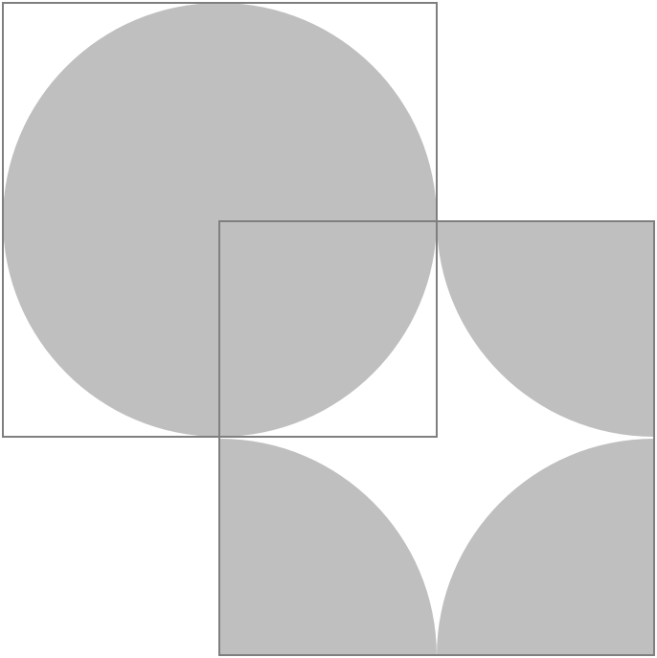
Upper left: K-space as it should be shown in the UI
Lower right: K-space as it is used by JTransforms

Hanning filter
An apodization function, also called the Hann function, frequently used to reduce leakage in discrete Fourier transforms. The illustrations above show the Hanning function, its instrument function, and a blowup of the instrument function sidelobes. It is named after the Austrian meteorologist Julius von Hann (Blackman and Tukey 1959, pp. 98-99). The Hanning function is given by:

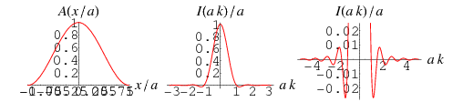

W: http://mathworld.wolfram.com/HanningFunction.html

Help text

Introduction
Understanding K-space starts with understanding your car audio displaying a frequency spectrum while music is being played. The car stereo evaluates a piece of audio signal and somehow extracts information about the frequencies from it.
The audio signal is a variation of signal over time. If the signal varies more rapidly over time, the frequency of the tone is higher.
If two tones are played at the same time, the signals are added together. The more tones are played at the same time, the more difficult it becomes to recognize the frequency of each tone.

Fourier Transformation
Without going into too much detail… The process of analyzing an audio signal and extracting the frequencies and amplitudes of all tones in the music is done using a Fourier Transform. By analyzing a short fragment of the audio data a Fourier Transform produces a graph that shows for each frequency its contribution in the analyzed audio signal.
Information that was in the time domain is now converted to the frequency domain. The algorithm computers use to perform this transformation is called FFT (Fast Fourier Transformation). Applying the similar transformation again to the frequency data reverts back the original audio signal.

FFT in MRI
In MRI scanners, for each row in an image a FFT is required to transform the signal from the time domain (as picked up by the coil) to the frequency domain. And then another FFT is required for each column to decode the phase information as well. This process is referred to as a two-dimensional FFT or 2D-FFT.
The matrix that holds the data as it is recorded from the MRI scanner is known as the K-space. In most cases a single line of data is acquired every repetition time. A scan completes when all lines required have been measured.

Artifacts
Many of the artifacts that occur in MRI images can be explained as a result from this 2D-FFT. If information in the

Software used

Processing 3.2.1 (Linux-64)
Processing is a flexible software sketchbook and a language for learning how to code within the context of the visual arts. Since 2001, Processing has promoted software literacy within the visual arts and visual literacy within technology.
W: https://www.processing.org

JtransForms 3.1
JTransforms is the first, open source, multi-threaded FFT library written in pure Java. Currently, four types of transforms are available. The code is derived from General Purpose FFT Package written by Takuya Ooura and from Java FFTPack written by Baoshe Zhang.
W: https://github.com/wendykierp/JTransforms

Android Mode 0250 (3.0-RC4)
Processing for Android allows you to create Android apps using Processing. You can run your Processing sketches on Android devices with little or no changes in the code. You can also export your sketch as a signed package to upload to the Google Play Store.
W: http://android.processing.org/

Ke:tai v12
Let’s you create mobile apps using Processing. Ke:tai is good at everything a mobile Android device does, and the desktop doesn’t. It’s a extensive library that gives you straight-forward access to sensors, cameras, and networking hardware.
W: http://ketai.org/

Android Studio 2.2.1
Android Studio provides the fastest tools for building apps on every type of Android device. World-class code editing, debugging, performance tooling, a flexible build system, and an instant build/deploy system all allow you to focus on building unique and high quality apps.
W: https://developer.android.com/studio/index.html

Linux Mint 18 “Sarah” Cinnamon edition
Linux Mint 18 is a long term support release which will be supported until 2021. It comes with updated software and brings refinements and many new features to make your desktop even more comfortable to use.
W: https://www.linuxmint.com/

Inkscape 0.91
All icons designed in Inkscape,
W: www.inkscape.org

Gimp 2.8.16
All MR images acquired with Philips Achieva and processed in Gimp.
W: www.gimp.org

Appendix A: Lifecycle android app

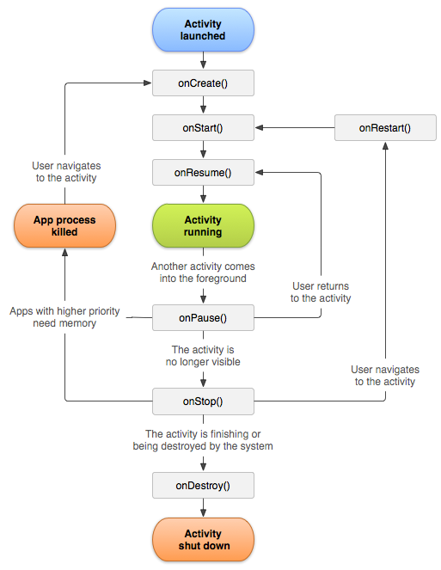
W: https://developer.android.com/reference/android/app/Activity.html

